Macintosh HD:Users:alobue:Dropbox:Saint Ignatius (1):Academics:School Logotypes:Centered:Seal & Tag:SI_Logotype_Centered_2Color_Seal&Tag_CMYK.eps

March 2021

Dear Parent/Guardian:

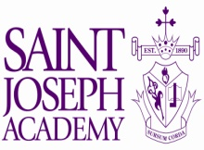Once again we are writing a joint letter enlisting the support of senior parents in ensuring a safe and happy prom and graduation for our students. We write to you out of the same care and concern for the Class of 2021. This is a wonderful group of young men and women who have worked hard and deserve a happy, yet festive, end to a great school year. We do not want it to be spoiled by incidents involving alcohol, illegal underage drinking, car accidents, or hotel/motel parties. We want to work with you to ensure the safety of our young people.

The 1989 Amendment to the Ohio Revised Code Section 4301.69 (commonly known as the “Keg Law”), holds individuals responsible for underage drinking on property under their control. If an after-prom party is held at a private home, for example, and the parents knowingly allow underage persons to consume alcoholic beverages, both the underage persons and the parents are in violation of the law. Violation of the “Keg Law” is a FIRST DEGREE MISDEMEANOR, punishable with up to SIX MONTHS in jail and/or up to a $1,000 FINE. Also, the parents may be held civilly liable in the event that an underage person is involved in an alcohol-related accident.



The “Keg Law” also includes hotels, motels, campgrounds, and other public places that they NOT KNOWINGLY allow underage drinking parties to take place on their premises. They are still subject to criminal prosecution and are held liable. Local hotel/motel managers are aware of this statute, and police and sheriffs’ departments throughout Ohio are ensuring enforcement.

We would also like you to be aware of the following. In Ohio, parents may be held liable for any injury or damage caused by a teenager who has been allowed to drink in their home. Any person under the age of 21 who provides false identification for the purpose of purchasing alcohol is guilty of a crime.

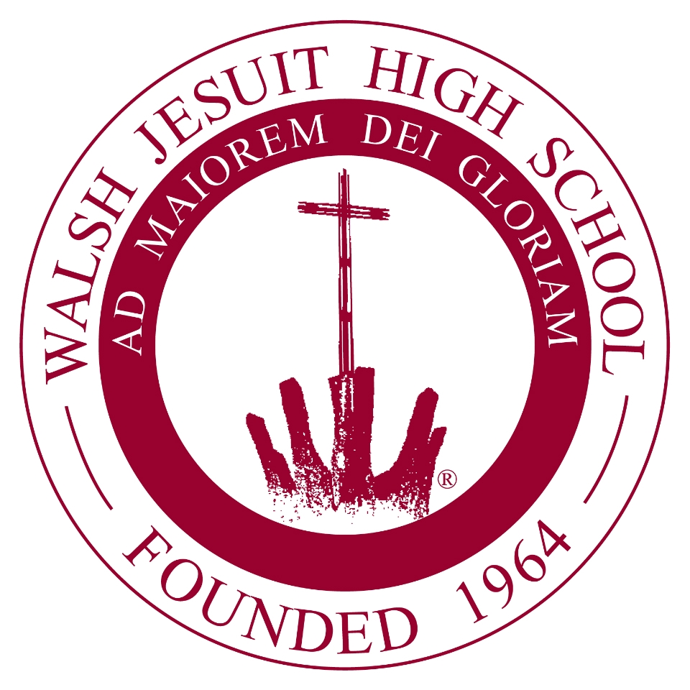

Schools and Project CARE are working together to assure that our students are safe and enjoy their senior-year events. This letter represents a combined concern and effort of a number of schools in the Northeast Ohio area in addition to our own.

We hope you will join us by promoting a drug and alcohol-free prom and graduation.

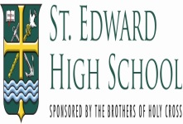Sincerely,

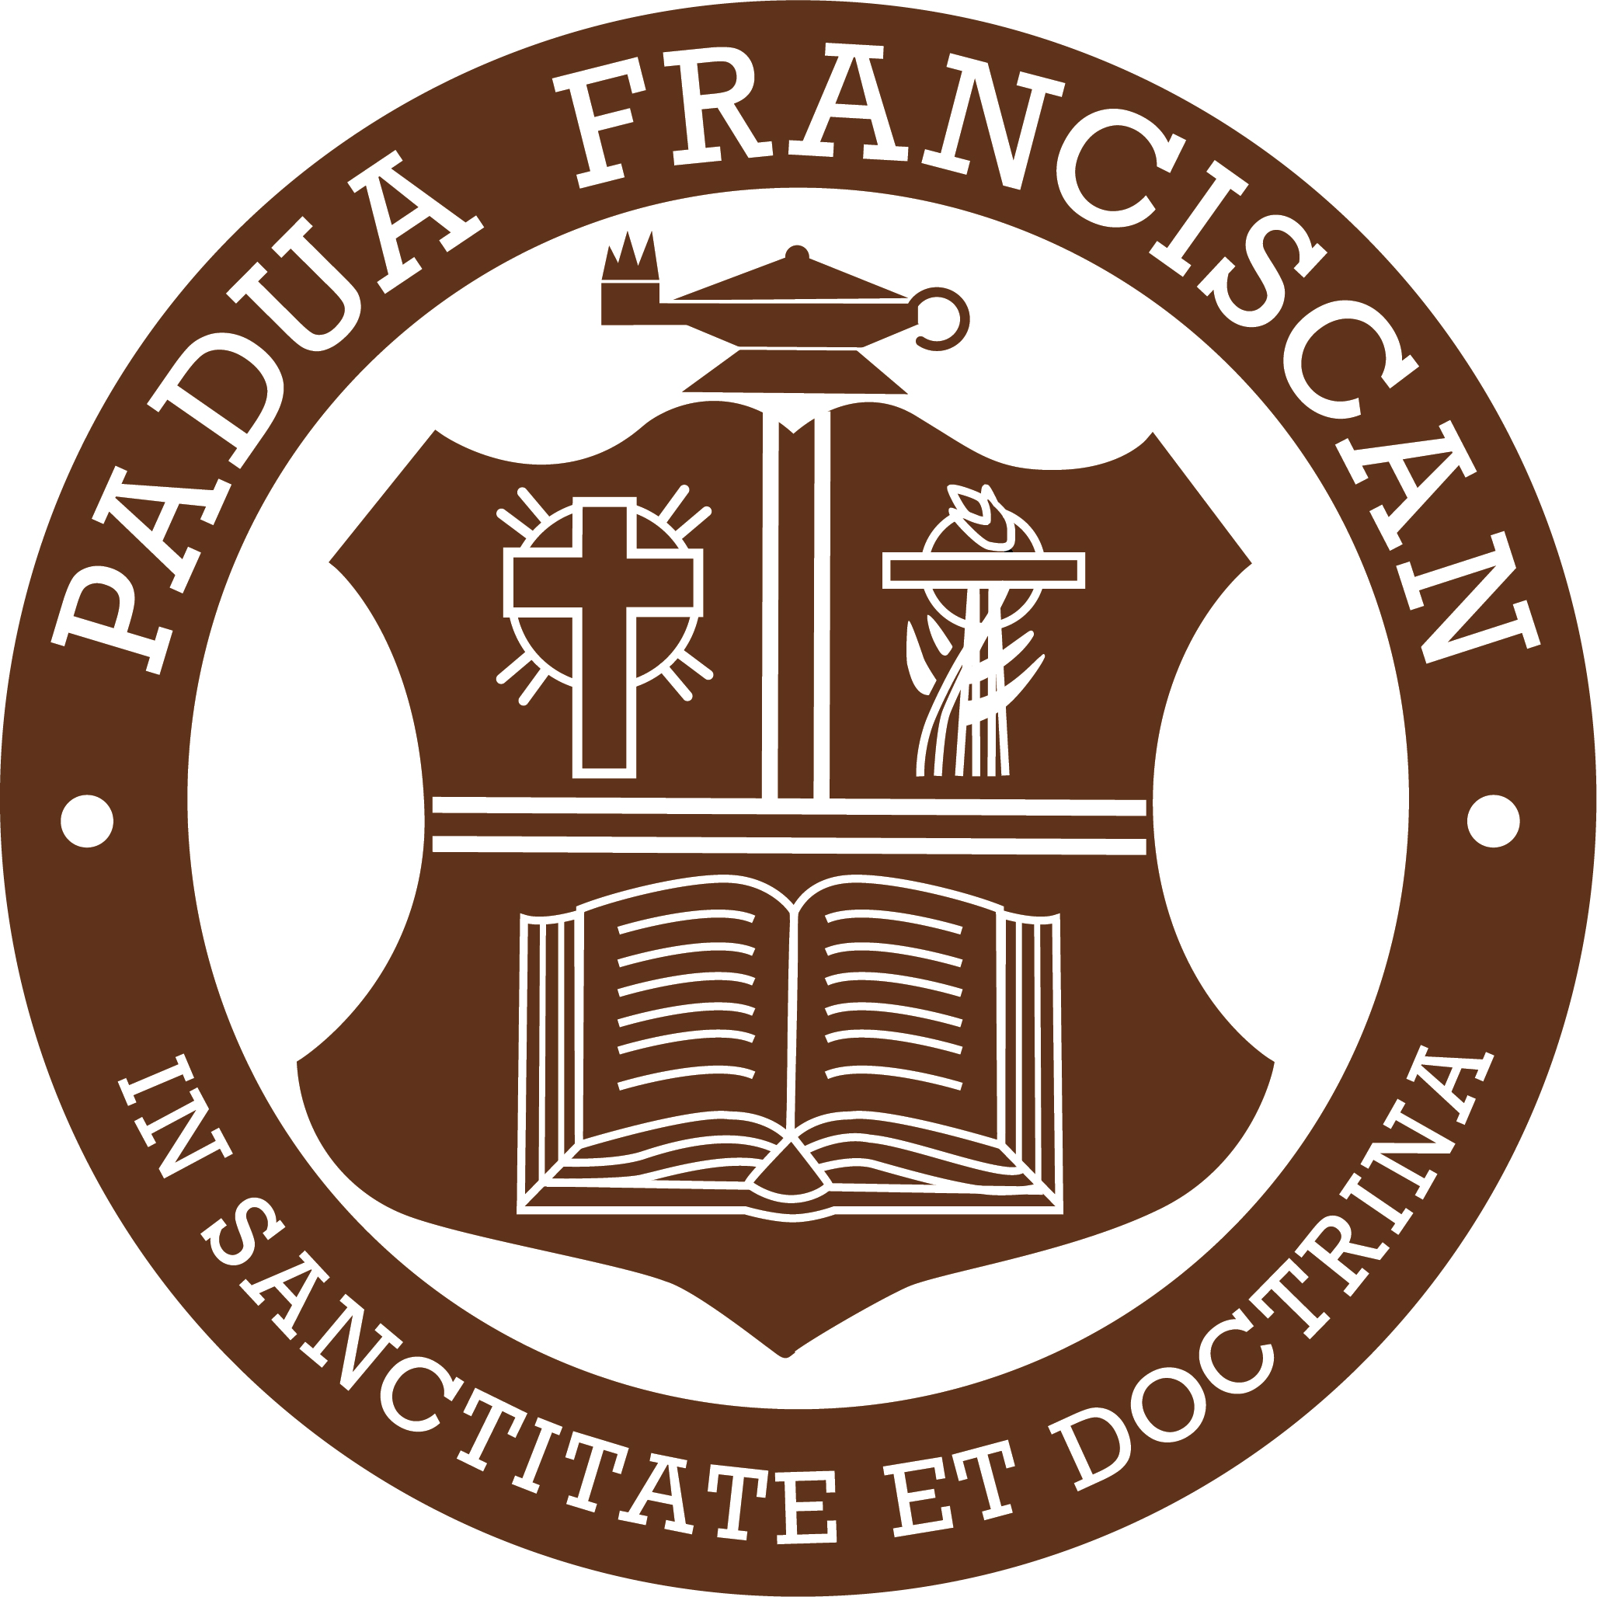

**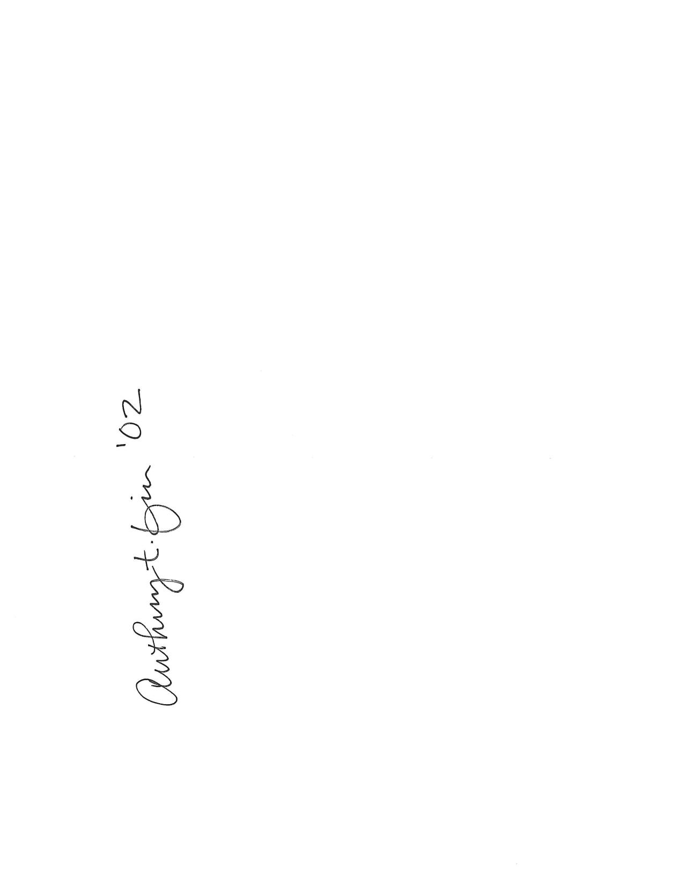**

Dr. Anthony T. Fior ’02

Principal, Saint Ignatius High School



Mr. Jeff Sutliff

Principal, Saint Joseph Academy

C:\Users\chyland.MAGNIFICATHS\Downloads\mtdwyer sig.jpg

Mrs. Mary T. Dwyer-Kueller

Dean of Student Life and Formation

Magnificat High School

**NEED NEW NAME PLEASE**

Principal, Walsh Jesuit High School



Mr. Nick Beyer

Principal, Beaumont

**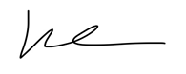**

Mr. KC McKenna

Principal, Saint Edward High School

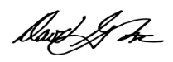

Mr. David Stec

Principal, Padua Franciscan High School