IB Extended Essay
May 2018

How does Jordan Peele's Get Out go against and or represent the modern portrayal of African Americans in US media and culture?

Subject Area: Film
Word Count: 3,812

Table of Contents

Introduction…………………………………………………………………………………………….2

Racial Climate…………………………………………………………………………………………..3

Natural Lighting………………………………………………………....……………………………...6

Cameras and Screens……………………………………………………….…………………………10

Hunter Archetype & The Deer………………………………………………………………………..13

Conclusion & Connections to Overall Themes……………………………………………………..16

Works Cited.…………………………………………………………………………………………….19

Jordan Peele’s Get Out and
Race Portrayal in America

Introduction
The representation of African Americans in media, films, and television is and always has been ever-changing in the United States of America. Once slavery was abolished in 1865 in the 13th ratification, African Americans still could not enjoy the same privileges of White Americans. For example, that of simple voting rights (NARA). Segregation, written in national legislature of the “Jim Crow laws”, allowed for Black Americans to be viewed as permanent second class citizens. The naming stemming from the infamous, and popular American song, “Jump Jim Crow” written by Thomas Dartmouth Rice. The piece created a whole popularized portrait, while being atrociously unjust, to an entire race of people, so much so that laws were notable and named after it (Urofsky). However, the ill-representation of African Americans through media did not stop there.
The US saw some of the first depictions of African Americans in mass media throughout their movie-making industries. One of the earliest examples of the representation of African Americans in mass media culture can be seen in the infamous 1915 film Birth of a Nation. The film played as a propaganda piece to prop up the White supremacist group, the Klu Klux Klan. Enforcing gruesome and hateful racial stereotypes such as attributing African Americans to simple minded and uncontrolled. What Birth of a Nation did to its American audience was display that Black people can be used for White people's’ amusement and entertainment. The movie also furthered White supremacist as an ideology to Americans as it literally showed the KKK “save the day” from unsafe African Americans. In cinematic terms, as seen in Figure 1 below, with the usage of “Mise en Scene”
or the objects within the shot, Director D. W. Griffith illustrates that Gus, in “black face”, is threatening. Griffith does this by altering the costuming of Walter Long as “Gus” to show protruding collar and sternum also along with his torn clothing. In similar distaste, the improper representation of African Americans in recent history does not end there. Audiences would see that of American minstrelsy shows, meaning the portrayal of Africans Americans as lazy carefree in a theatre setting. A practice which lasted for a century even after the ratification of the thirteenth amendment. Not until the 1970s did the practice diminish from national television. However, tokenism in art itself, the idea of African Americans sheerly for the public’s entertainment, can be argued that it is still not out of the arts yet.
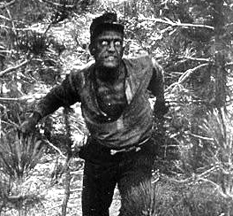
Figure 1: Walter Long in “Blackface”, Birth of a Nation (1915)
Image courtesy of http://www.cineoutsider.com
Racial Climate Now
The Black Lives Matter movement started in the United States shortly after the shooting and murder of Trayvon Martin, a 17 year-old African American, in Florida. This movement recently gained increased traction and support after the additional murders of Eric Garner, strangled to death in New York and Michael Brown, shot by police in Ferguson Missouri, and still attains new support as more and more African Americans are killed unjustly in the United States. The movement itself serves as political protest to acknowledge the injustices of that violence (Garcia). The situation is commentary showing that in some aspects, Americans are still divided in many ways. Comedians can often pull from this division and joke of these circumstances, albeit providing some criticism of the division.
Jordan Peele, the director, writer, and producer for the film Get Out, had been commonly recognized for his roles in shows and films such as Wanderlust and as a five series cast member of MADtv . However he is likely most notable for making up one half of the prominent comedic duo Key and Peele, to which they started their own show composed of satirical skits primarily satirizing American “Pop-culture”. Peele was born in New York City in 1979, to a biracial couple, though later to being raised predominantly by his Caucasian mother (Kettler). He credits much of his comical twist upon social and racial climate with his upbringing. He notes in an interview with CNN in 2012,
For me it was very hard and rough. When you're a child, the most important thing is to be able to live a life of comfort. You want to be sure that the moon goes up at night and the sun comes up in the morning and dad comes home from work. At school it was not comfortable….My mom would come by my school to bring me lunch – my mom is a cute, ruddy little White woman, and there's no category for that – the kids don't know how to respond, and so they tease: 'That ain't your mama!' 'Why you talk White?' It's not to say that every child in grade school talked to me that way, but that's what I remember.

Peele’s name and his roles became synonymous with comedy, however he would go against that image in his latest film, Get Out. Referred to as a “social thriller” by Peele himself, Get Out, while still containing some aspects of comedy, is serious, and quite so in its hidden meanings and messages that Peele displays throughout the film. What Get Out also excels on, different from much of its fellow thriller and or horror films, is that the film depicts social scenarios mostly unseen to the avid goers of films in these genres. A great example of this is that of the opening sequence the film starts to. Andre, played by Lakeith Stanfield and also an African American, is walking through a White suburb and is completely fearful. Peele also up plays a sense of him being “stalked” with dramatic low-key lighting through the duration of this scene. He claims in an interview with youtube channel Blacktree TV, owned by the Hollywood Post, about that scene that,

“What we’ve seen to be in actuality for the last couple of years, is it’s terrifying to feel like an outsider in a place that’s not necessarily welcome to you. So yeah, I wanted to take everything that’s scary about halloween, where they did this great representation about suburbia and how it's scary. . I wanted to take it up a notch, and y’know, put a Black person in there.” (Youtube Channel Blacktree TV)
Peele shows here a scenario that otherwise many White and some minorities would perhaps never feel in their life. It supplies the viewer some outlook on the experience of an African-American, and this is truly what this film is outstanding in. The film gives light to many experiences and real world situations that are possibly unjust woven into the horror narrative that Peele has devised. Furthermore Peele’s usage of certain cinematic devices, especially that of “Mise En Scene” and allegorical themes within Get Out provide supplementary emphasis on bigotry, closeted or not, that exists within The United States today. The way Peele introduces and presents a depiction of the Armitage Family, the main “racist” antagonists of the film, is especially key. This because he does so in a sense that on the exterior shows their racist viewpoints without the reveal of their true nature. This is shown much later in the film. This depiction can specifically seen in Peele’s manipulation and usage of “Mise En Scene”, i.e. the costumes, props, composition, etc.,

Natural Lighting
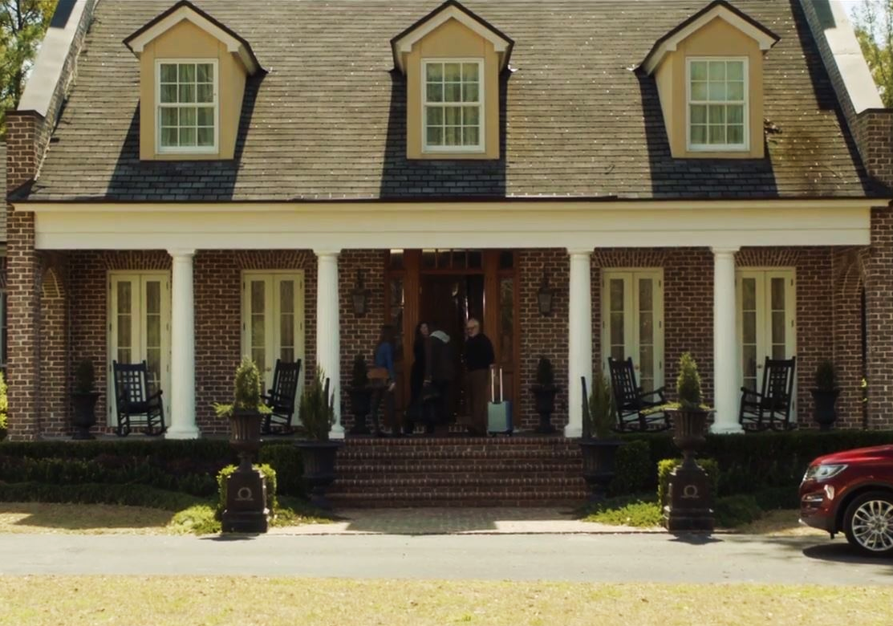
Figure 3 : Armitage House
Get Out as a horror film surprisingly remains in Natural lighting, commonly seen in the daytime, for a majority of the film rather than using more darker forms of lighting such as low-key lighting, mainly nighttime.
This turns the conventions of “horror” and what is to be expected as other iconic horror films like Scream (1996) or The Exorcist (1973) are primarily, if not mostly, occurring at night. For example within Scream, the sheer terror that occurs can be seen in a sequence like that of Casey Becker’s murder in her own house at night. Then, when the events in the film turn to day, less horror is presented, and no fear of death is immediate from the main characters.
Furthermore we see the horror in Get Out that exists, not safe from daybreak, in the actual daytime as well. This gives the audience a different perspective on the scares and gritty undertones when it exists even in the daytime.
I have noted the times below for which cycle is prevalent in the film in the chart include below and I have established a graph concurrent to it.
Figure 4:
Film Timestamp | Day/Night Cycle | Total Time
0:00:00 - 0:03:45 | Night | 03:45
0:03:46 - 0:21:50 | Day | 18:04
0:21:51 - 0:36:48 | Night | 14:57
0:36:49 - 1:02:37 | Day | 25:48
1:02:38 - 1:10:49 | Night | 08:11
1:10:50 - 1:18:57 | Alternates (Interior/Investigation Scenes) | N/A
1:18:58 - 1:40:22 | Night | 21:24
Averaged using http://www.calculator.net/time-calculator.html

Total Night - 40:06 or 2406 seconds
Total Day - 43:52 or 2632 seconds
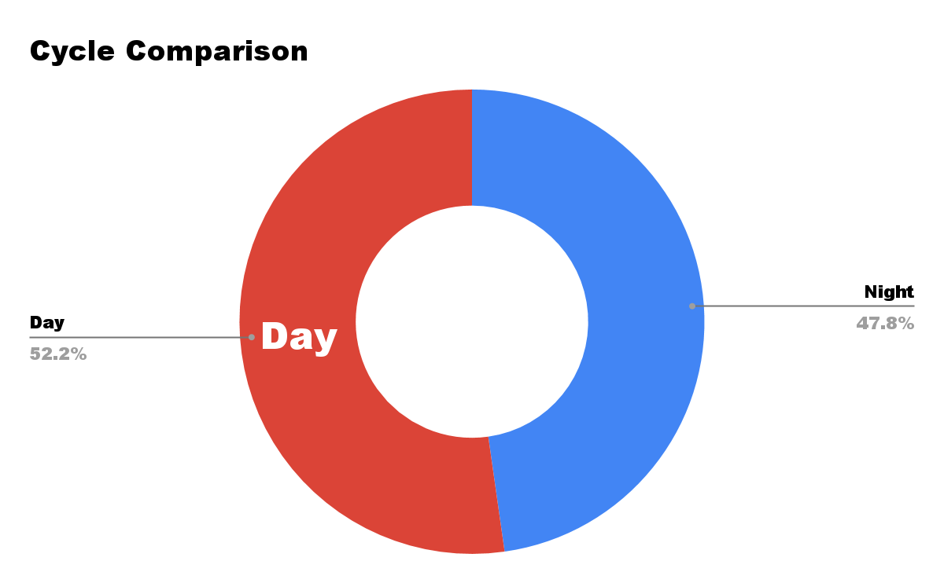
Figure 5 : Cycle Comparison made in Google Sheets

Natural lighting, predominantly used in daylight shots, occurs when the lighting in a scene is bright and balanced throughout. Within its context, natural lighting portrays an almost “daily” setting. In this aspect many filmmakers often use natural lighting in light-hearted environments to suggest that a situation is normal. This is what I believe Peele is using here for his outdoor family gathering sequences. By placing Peele’s depiction of real social horror, for example the auctioning off of Chris, within the pleasantly lit daytime, it would say that this mysterious and off putting behavior can be almost “everyday” in society. The scene I am discussing, is when prior to Chris’ realization of his own capture into enslavement. The Armitage Family holds an event in which is presented as a family gathering to Chris, however, is really a cover for selling his body to the highest bidder.
When the situation turns night time it is fully revealed, their nature and dangerous racist ideas. Furthermore on the same topic, the cinematographer of Get Out, Toby Oliver discusses in an interview with entertainment website WheretoWatch ‘s Kelle Long,
.....We really wanted Chris' world in the city to feel really natural and real and when they arrive at Rose's estate, it would be very warm, a golden glow to the outside and also the inside of the house. It would feel very inviting and very welcoming. When the parents meet him on the doorstep and invite him in and show him around, everything feels nice and inviting and friendly, and we want to reflect that in the color and the lighting. Underneath, something very weird and strange is going on, which Chris slowly starts realizing...(Long, 2017)

Toby Oliver is explaining why the film was in daylight for the introduction sequence, when Chris first arrives at the armitage house. The same lighting is also used, as seen in Figure 5, throughout a majority of the film. Specifically the sequence of the auction scene where Chris is exposed to more racial opinions about him. What Peele tries to depict here with the natural lighting in scenes like that are unique in comparison to other horror films. Why he uses the natural lighting so frivolously during dire sequences is due to the fact that he wishes to depict the realness of the prejudices that ensue. And in this case the prejudices are the horrors. He tries to explicate that it’s not unlikely that you could see the same thing in your life if you were a minority in a situation like this, being outnumbered. Peele is also suggesting that horrors such as these could be seen within plain sight (by daylight) and exist in the open. In conjunction back to my arguments on the idea of closeted racism in our society, Peele, by placing the horror in daylight, is suggesting that it exists all around us and not simply at night.

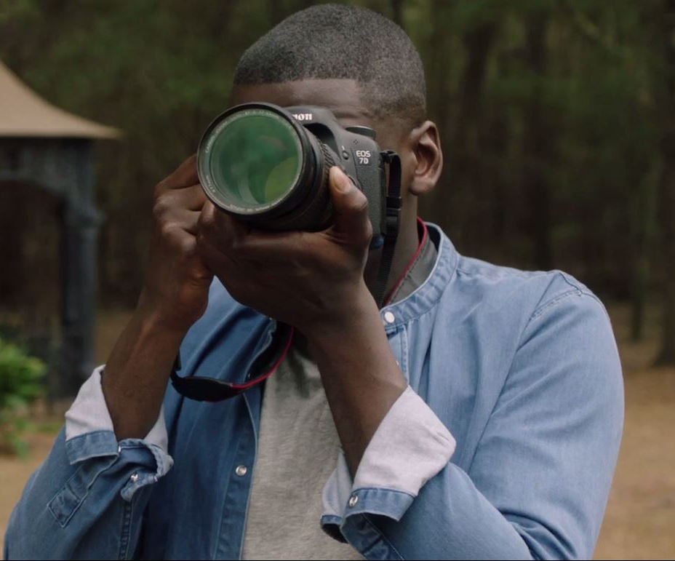
Cameras and Screens
Figure 9, and Figure 10, Chris observing the Armitage family with a camera

Another main motif in and within the film itself is its usage of lenses and particularly the framing of cameras. This in that the audience can visualize how a camera could affect a viewer's perception. In relation to a Theory of Knowledge standpoint, the perception of these events use a “Way of Knowing”. The “WoK” discussed here will be that of emotion or memory in Chris’ and our viewing. Specifically this is directly tied to Chris and his perception of the Armitage family during his stay. The viewpoint of a camera and seeing through a “lense/screen” is an extension of Chris and how he’s lived his life so far. Glued to a tv screen during his mother’s death, as we saw during the first act, Chris doesn’t acknowledge it directly but, screens and viewpoints have been pivotal in his life, he is almost dependant upon the usage of them. This is specifically tied to a “memory” way of knowing due to the fact that it relies on past knowledge and experiences.
Often times the camera provides support and almost a safe haven to the things he witnesses. Like that of a protective shield, Chris uses his viewfinder (the lense within his camera) as a crutch for him to actually see the true horrors of the Armitage family. Lenika Cruz, writer for The Atlantic, claims “The camera simultaneously creates distance and closeness between Chris and his subjects; it’s a way to both observe and to escape” (Cruz 2017)
The same abilities that Chris gains from the camera is synonymous with the usage of one in society today. Chris uses his camera as support which gives him power and buttresses him. In a similar sense cameras today, exist with grander importance. Particularly with the rise in media coverage of police shootings upon Black lives, the camera and the ability to record events is extremely powerful. One can now show truth, of events, by simply taking advantage of a simple feature that many if not most of the millennial generation have, a smartphone and the ability to record.
We see this usage of the camera to display injustices everyday. A very notable example being the murder of Philando Castile in the state of Minnesota in the United States. Castile was killed by a police officer after being pulled over. The officer asked to pull out his license and registration, to which he wanted make sure the cop knew had a concealed carry gun and license. While reaching for his driver's license Castile was shot four times out of claimed “fear of death” (Judge Choi during the ruling, 2016) by the officer, with his girlfriend’s four year old daughter in the backseat. The girlfriend to which, livestreamed the aftermath of the shooting to the internet to show how terrifying and unjust the situation was.

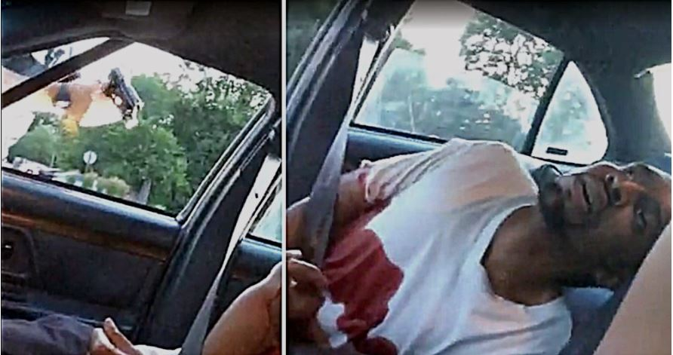
Figure 11: Death of Philando Castile
Dual capture from Diamond Reynold’s (Castile Girlfriend) livestream
source:https://photographyisnotacrime.com/2016/11/minnesota-cop-shot-killed-philando-castile-charged-manslaughter/

The footage itself (seen in Figure 11) was useful in the court case sentencing that Minnesotan cop a manslaughter charge. It was a factor in discerning whether or not the cop was guilty or innocent (Miller). And although that cop was later acquitted, the footage was vital in support for the initial charge, much like how Chris’ camera had been important for being support to him as well. Peele is simply trying to hit on some of these real world events in connection to his broader theme within Get Out, which is that of how a minority like Chris, is forced to view societal horrors.

Hunter Archetype & The Deer
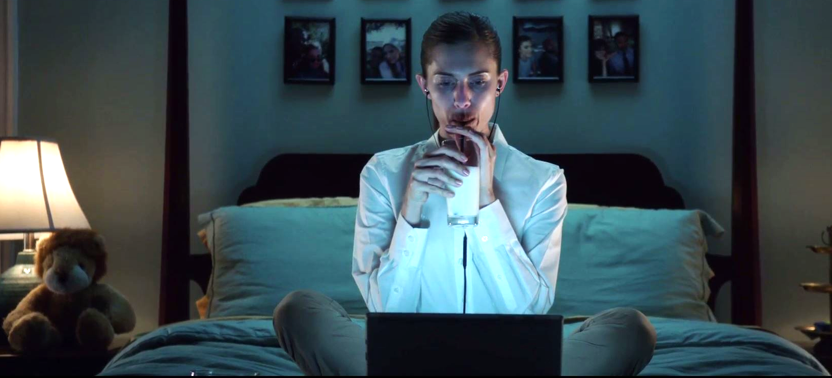
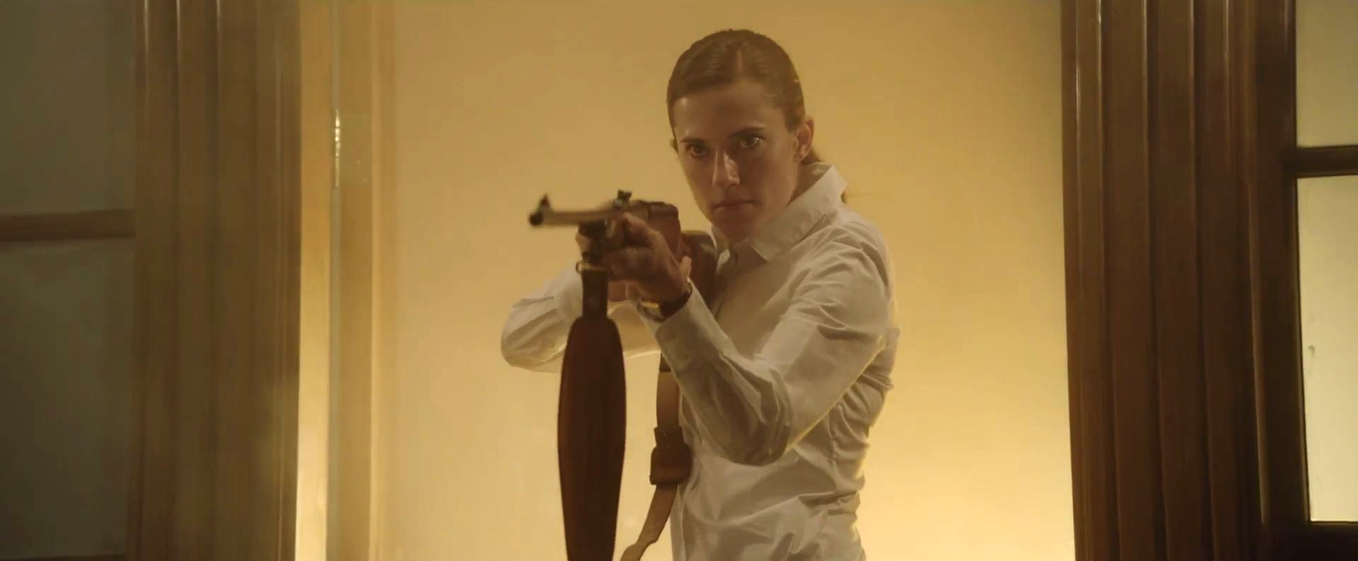

Figure 12: Rose as the hunter in 2 separate frames

Rose appearing to be confidant and lover of Chris for the majority of the film, turns out to actually be perhaps his greatest enemy. Showing her true intentions for Chris nearing the last 20 minutes of the film. Rose betrays him, revealing her to be the one who led Chris on the whole time. The film uses the symbols of the “hunter” and the “prey” in great amounts and draws parallels between that and the Armitages and African Americans. A great example of this can be seen in Rose in the same third act. In reference to Figure 12, Rose is the primary hunter and the most genius out of her and her brother. Her brother also fits this archetype of the “Hunter” as we saw in the opening scene in the movie where it is him who subdues Andre. All the while, the track “Run Rabbit Run” by Flanagan and Allen. Symbolizing that of the hunt itself as rabbits are seasoned prey during specific hunting seasons. However as we see when looking back at the plot of the film, Rose’s hunting strategies are entirely different than brute force.
What makes her a “genius” or so labeled by Rod, is that she scopes out her target and, like a long con, makes them, and in this case Chris, trust her. She deceives and in the end, eventually, gives them over to her parents for the final stage of “the coagula”. Peele hints at the archetype heavily within one particular sequence of the film. It’s Rose in her room, after searching for “Top NCAA prospects”, meaning further prey, the camera encloses outward to show Rose’s room entirely. Peele carefully handpicked the Mise en Scene in this sequence, to all fit the archetype of a hunter. For example, we see in the background, or wall of Rose’s room (Figure 12) all of her past relationships she hunted and gave over to her parents. They serve as trophies upon her wall. Also the stuffed lion on the desk and milk she drinks. Relating her to be a lioness of sorts, stalking her prey and then “pouncing on” (capturing)

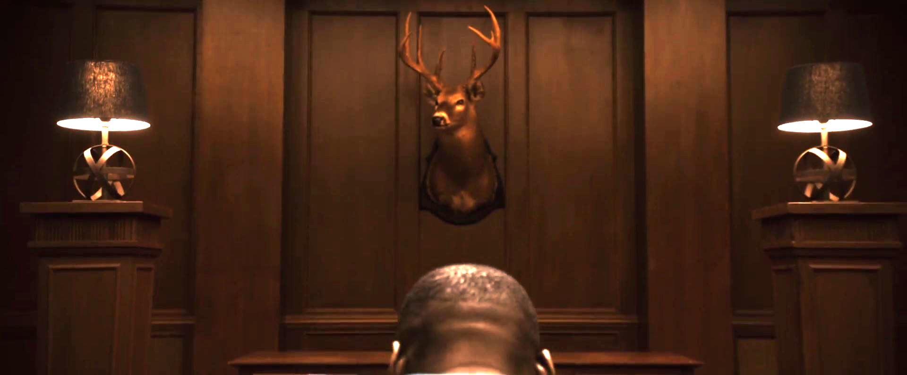
Figure 13: The Deer and Chris

This comparison in the film is vital in relating how the Armitage family, views African Americans. Peele uses the hunter archetype, and portrayal of an African American (captured by the Armitages) as prey. Peele also uses the symbol of a deer to much length and how it is somewhat synonymous with Chris and Rose’s other partners as prey. It simply shows the racist ideals of the Armitage family with the usage of that symbolism. Meaning the connection of forest animals, specifically like the deer sitting across from Chris in this frame (Figure 13), to Chris and his journey. The Armitages use the bodies of African Americans like hulls doing whatever they please to them. Peele simply hints to the fact that this, almost like ideal modern day slavery, is the full exploitation of a Black American. What the Armitages are doing is identical to minstrelsy, i.e. using Black Americans for the full entertainment of White people. Peele’s also highlighting also that while them being not traditionally racist, this is. The Armitages think of Black Americans as specimens and justified hunted animals to them.

Conclusion & Connections to Overall Themes
Get Out, in my opinion, serves a staple in films released in the 21st century for displaying racial themes in a completely unique way. It even shows the racial themes in its many cinematic devices and themes unknowing to the viewers of the film. If someone was to simply watch Get Out, completely expecting simple horror, they would also see, indirectly, undertones of the depiction of race and injustice in our society. Peele shows to the audience of the film that race in society, is still an issue today, even in the context of a bloody horror plot. We see Chris’ adversities, struggles, and triumphs as if we are with him and on his side. All the while, the horrors Chris faces are completely the result of closeted bigotry that exist everyday in America. It gives a slight perspective to all members of the audience that watch it, whether they’re White, Brown, Black, or any color. In fact, Jordan Peele also acknowledges this in his interview with Blacktree TV,
“This movie is very much about the issue of race and how It’s possible to deal with social issues without going at them head on. I really feel like this particular mixture of topic and genre was a missing piece of the conversation. The way we talk about race is broken right now. It’s very difficult for Americans to have a positive and constructive conversation.” (Peele, 2017)
The film allows the viewers to see race, or what Peele has experienced in his life, and even have a discussion about it. This, even without experiencing it yourself. We get some perspective into what it feels like to be entirely “different” to our surroundings and also the dangers that can arise from that. An example of this can be viewed in the ending of the film itself, in which Chris’ situation is enveloped in a real world sense with police.

Bonus: Theatrical and Alternate Ending
Police enforcement and specifically cops go hand in hand with Get Out. It seems as if based on the political climate of the United States, it would be impossible for Peele, when making a social commentary, not to reference or bring up the subject of police prejudice at least once in the film.
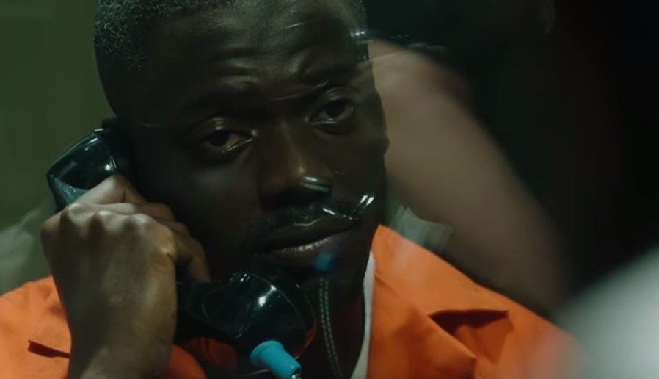
Figure 15: Get Out Alternate Ending from DVD Extras
The ending in the theatrical released film, had been, what is commonly known in the film industry as a “reshoot”. In fact in the supposed actual ending, now being the alternate, released in the digital extras of Get Out, is Chris encountering the police coming out of the car and gets sent to jail.
Peele shows that it’s almost predictable that an innocent Black man would be arrested and jailed than an innocent looking guilty White woman. He wanted to also portray here that Black Americans are more likely to be sentenced to prison unfairly when compared to a White American. In fact in 2014 as recorded from the US Bureau of Justice statistics, 37 % of the male prison population was consisting of Black men. However, as recorded by US Census Bureau, the total population of Americans with Black or African heritage in the United States on that same year was only 14% of the population.
Peele’s Get Out is simply presenting a feeling that is permanent and perhaps always will be. The idea of “closeted racism” in our society exists, whether we choose to see it for what it is, or not. By manipulating much of the Mise En Scene within the film, Peele can display the nature of that closeted racism and in which ways it can appear to us. Peele emphasizes that even if there is tremendous social change, i.e. the forwarding of liberal action, the experience of a minority within its majority, like an African American in the United States, can still be unequal.

Works Cited
Bureau, US Census. “Newsroom.” FFF: Black (African-American) History Month:
February 2016, US Department of Commerce, 1 Jan. 2016,
Carson, E Ann. “Prisoners in 2014.” Bureau of Justice Statistics, Sept. 2015,
Cruz, Lenika. "In Get Out, the Eyes Have It." The Atlantic. Atlantic Media Company, 03 Mar. 2017. Web.
Bureau, US Census. “Newsroom.” FFF: Black (African-American) History Month:
February 2016, US Department of Commerce, 1 Jan. 2016,
García, Jennifer Jee-Lyn, and Mienah Zulfacar Sharif. "Black Lives Matter: A Commentary on Racism and Public Health." American Journal of Public Health. American Public Health Association, Aug. 2015. Web.
Get Out. Dir. Jordan Peele. Blumhouse Productions, 2017. DVD.
"Get Out Interview with Jordan Peele." Interview by BlackTree Media. YouTube. YouTube, 13 Feb. 2017. Web.
Harris, Brandon. "The Giant Leap Forward of Jordan Peele's." The New Yorker. The New Yorker, 4 Mar. 2017. Web.
Horton, Yurii. "Portrayal of Minorities in the Film, Media and Entertainment Industries." Web.stanford.edu. Ethics of Development in a Global Environment, 1 June 1999. Web.
Kettler, Sara. “Jordan Peele.” Biography.com, A&E Networks Television, 20 Dec. 2017,
Long, Kelle. "Get Out's Cinematographer Reveals the Methods Behind Jordan Peele's Brilliant Madness." Wheretowatch.com. MPAA Inc, 29 Mar. 2017. Web.
Miller, Carlos. "Minnesota Cop Who Shot and Killed Philando Castile Charged with Manslaughter." Photography Is Not a Crime. Photography Is Not a Crime, 16 Nov. 2016. Web.
NARA. "13th Amendment to the U.S. Constitution: Abolition of Slavery (1865)." Ourdocuments.gov. U.S. National Archives & Records Administration, 9 Oct. 2017. Web.
Staff, NPR. "In 'Get Out,' Jordan Peele Tackles The 'Human Horror' Of Racial Fear." NPR. NPR, 19 Feb. 2017. Web.
Siek, Stephanie. “'Key & Peele': The Color of Funny.” CNN, Cable News Network, 24 Feb. 2012,
Urofsky, Melvin I. "Jim Crow Law." Encyclopædia Britannica. Encyclopædia Britannica, Inc., 19 July 2017. Web.

